Azure App services which is the first service created by Microsoft azure, and for web app we need app service plan

1. Configurations: the settings will be defined based on the O.S we have selected

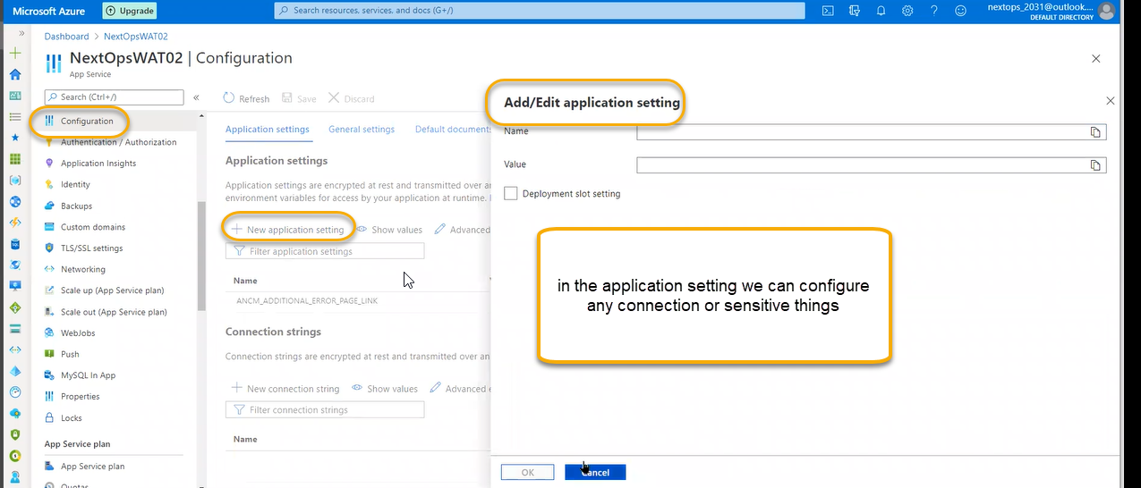

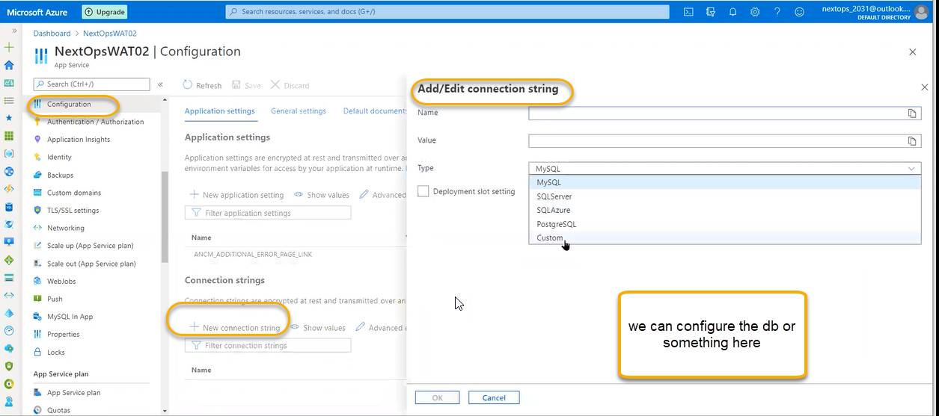

We don’t have any access to VM we can configure in application settings

Click on the show values we can see th error messages/or if we are not able to redirect it

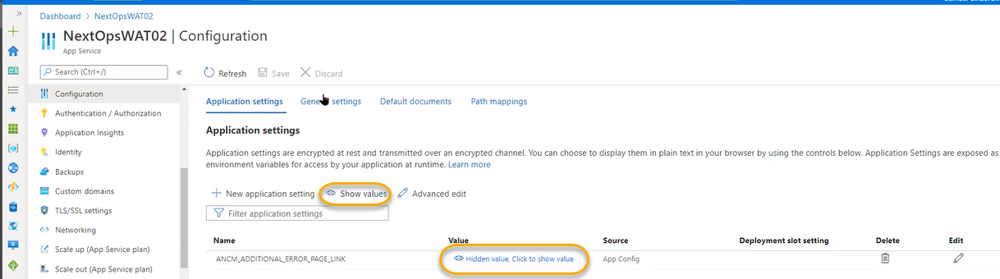

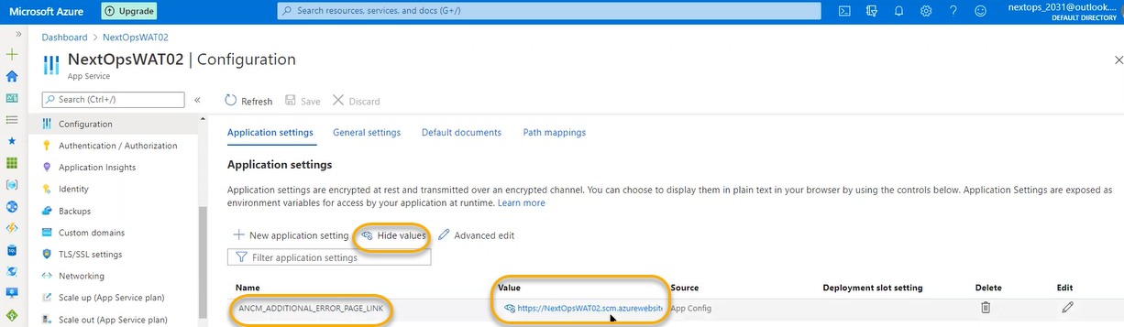

General settings:

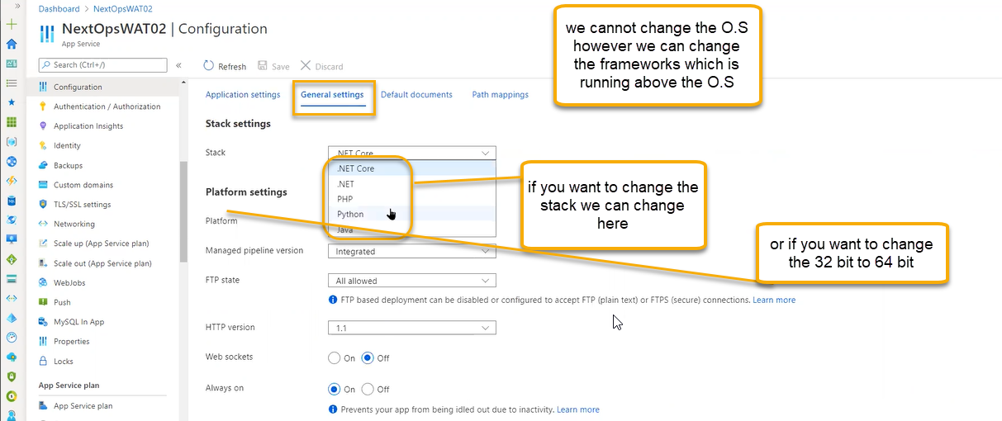

FTP we are not using we are doing it by source code repository and FTPS additional security

Web sockets: Long running application we will use like HTTP 2 version and we need to enable it

Always on in the IAAS we have worker process those will handle web applications/web request if the request will stop to web server automatically web server will be moved to auto state and if any new request came it will take time

ARR affinity: cookie-based affinity

Most of the time we will configure with the help of developers

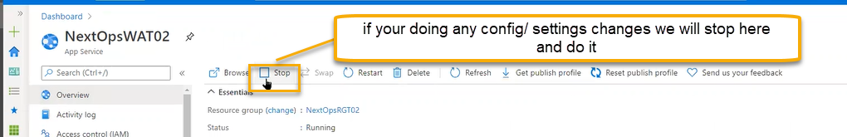

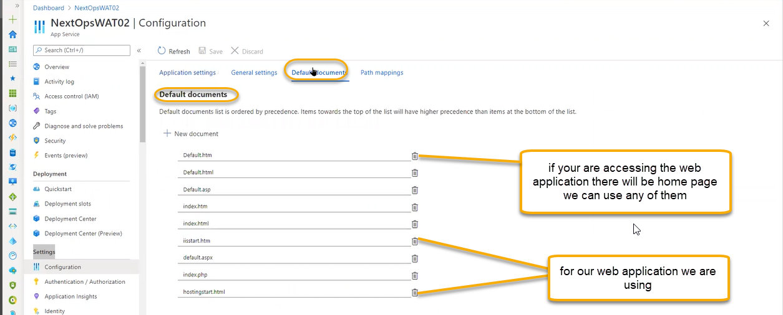

for our web services which documents are using we can see by below one configured

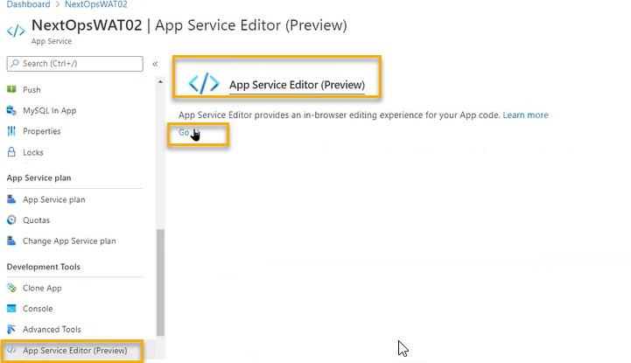

If you click on it

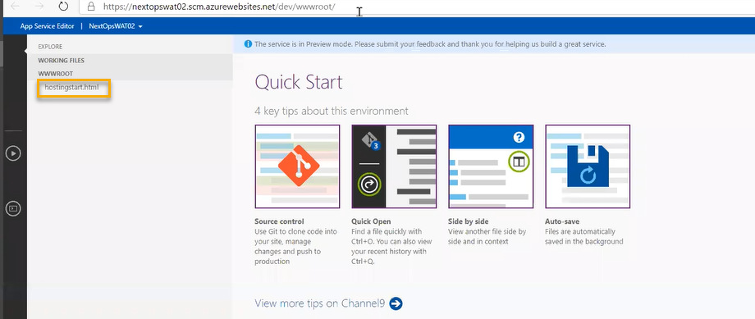

We must delete the default documents except hosting.html because we are using for our web page

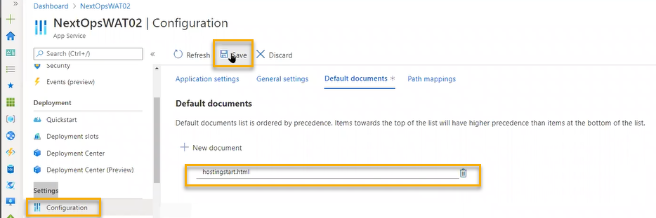

Path mappings: Handler mappings

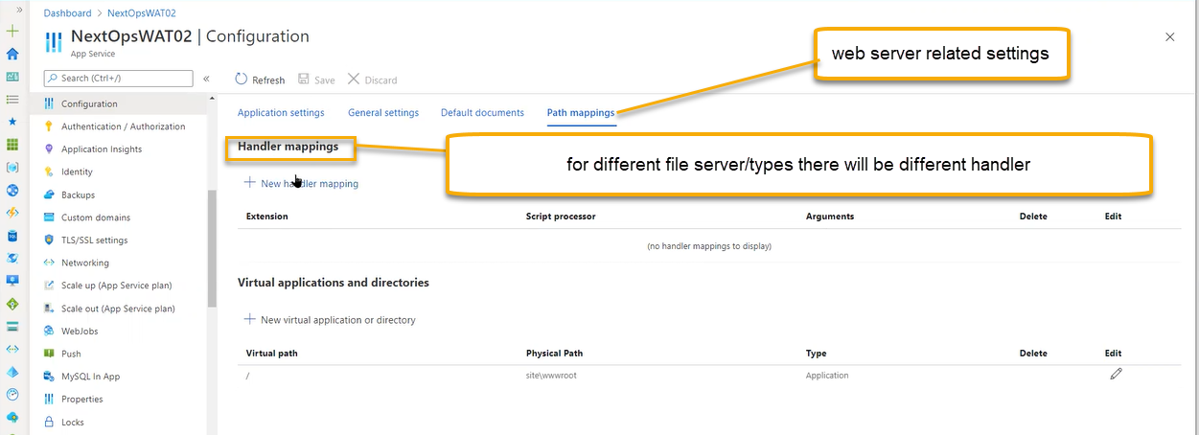

If you’re opening the pdf in your laptop then it will open it in Microsoft edge

And also, if you are printing any thing we can do it in the by handler mappings which extension it is

For passing the extension if we have scripts or Arguments, we can define it

We can do it in IAAS also

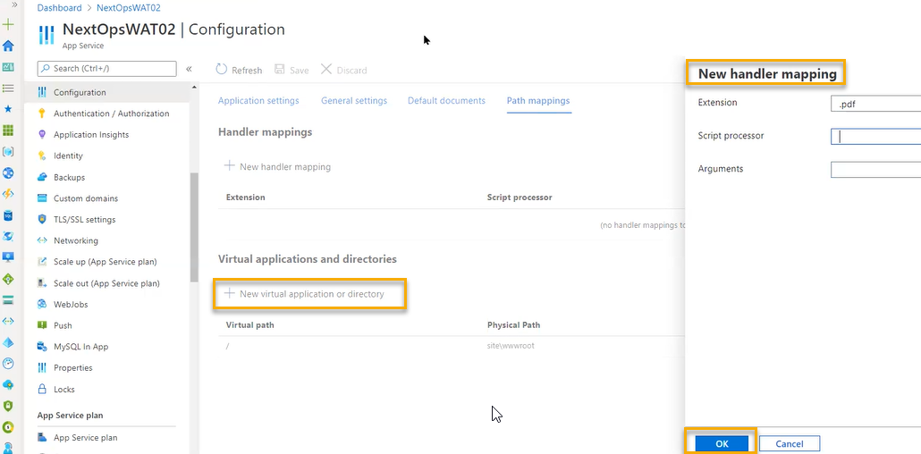

Virtual applications and directories

If you install the Internet services in the VM It will be stored in C drive/inetpub/ [www.root](http://www.root) folder

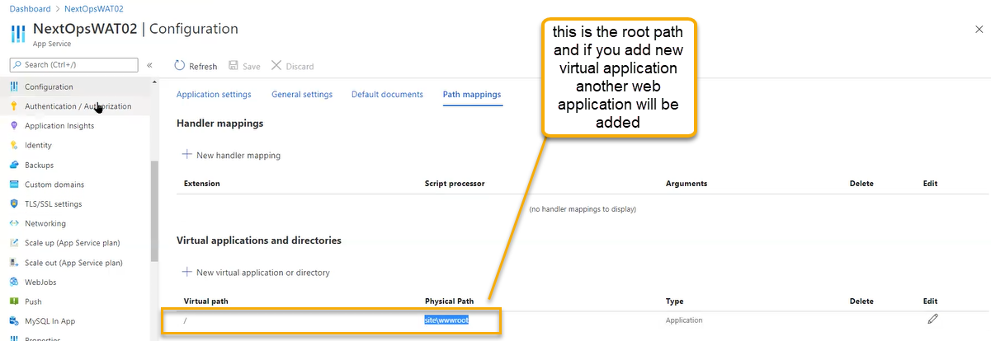

Authentication/Authorization

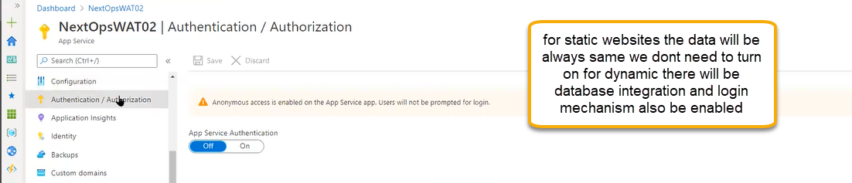

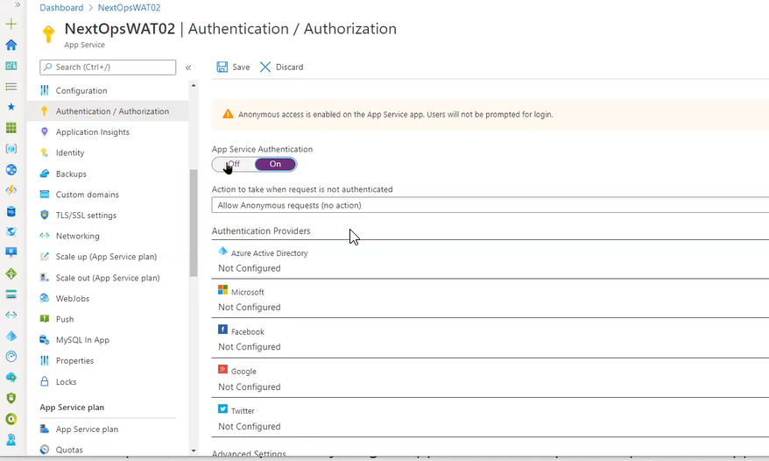

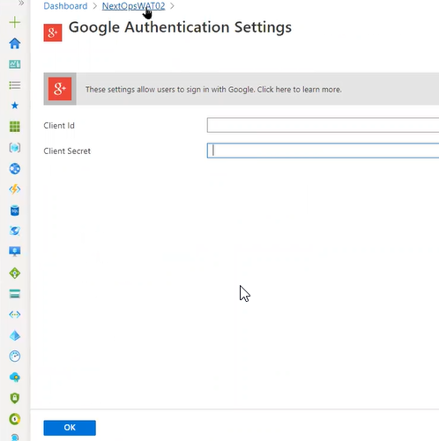

For application authentication we can do here if they develop, we can integrate here

Application Insights:

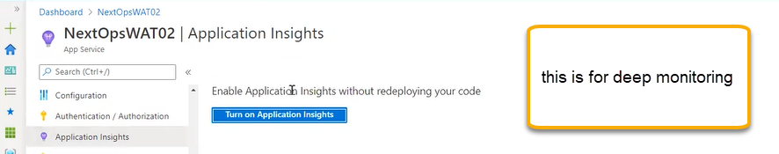

If we turn on we can see live metrics

Identity

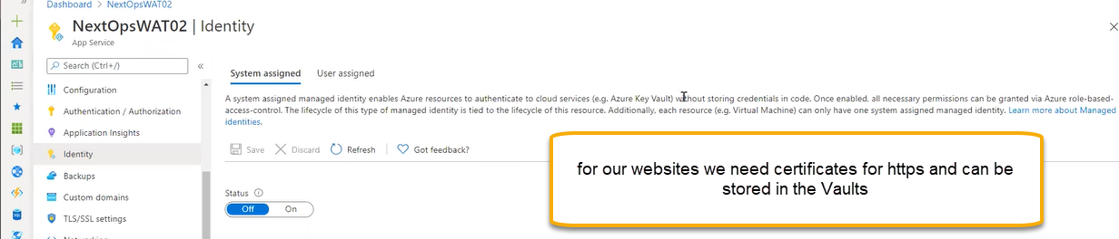

How the security we be associated we can do it by using the TLS/SSL Settings

For that we need to give access to key vaults so that we can access the options in TLS/SSL Settings

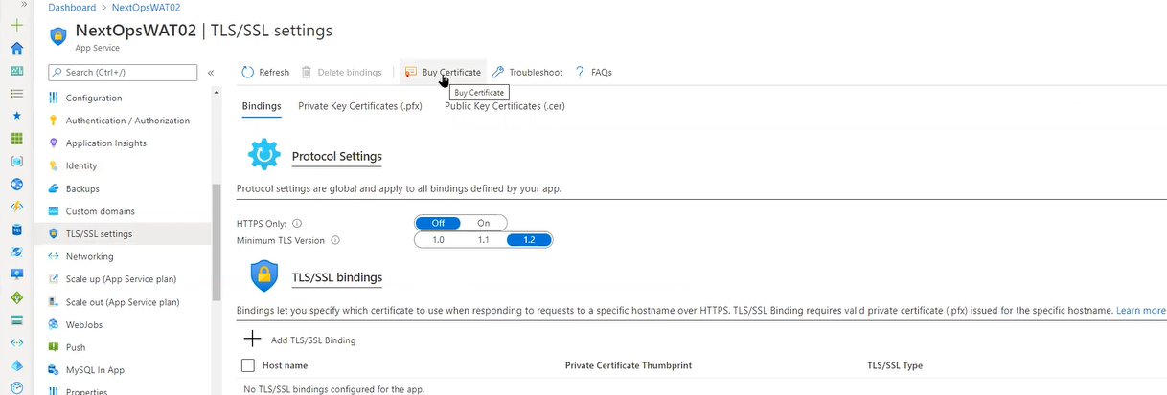

Backups

The web app specifically related is backups in site recovery/backup we can only VMS and SAP related however in these Backups related to only webapps

The backup will be stored in the storage account

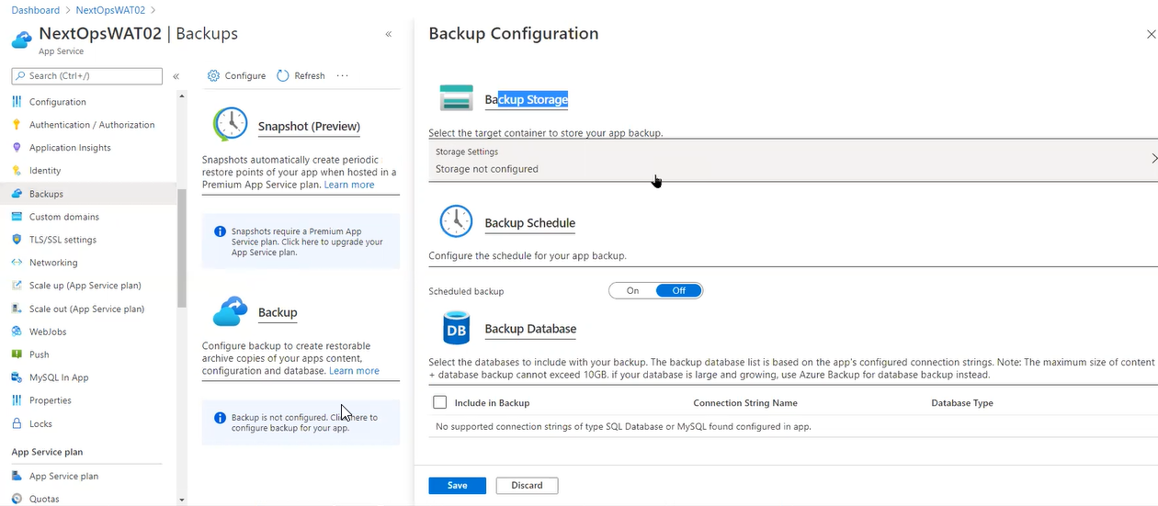

We can add it here

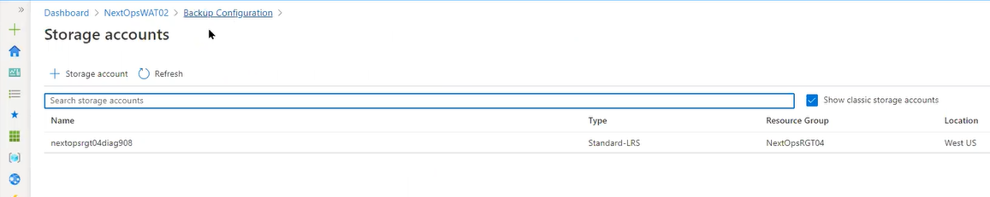

Back up schedule ON

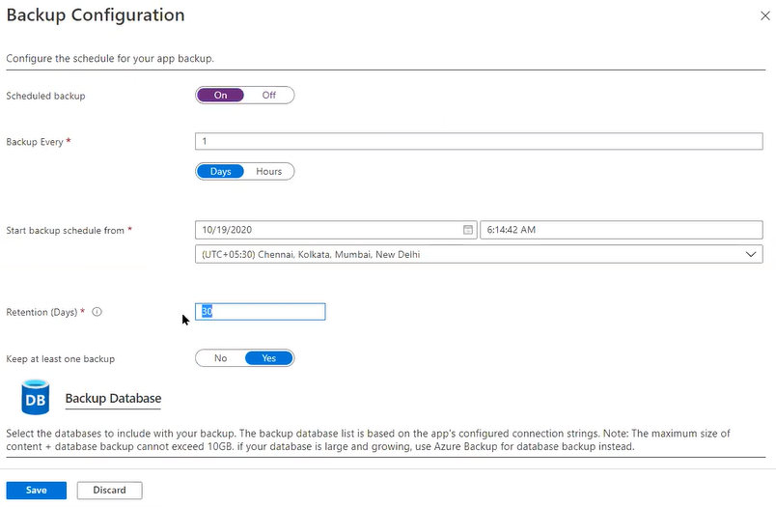

Backup database

If we integrate the database in this app server in the MySQL in App

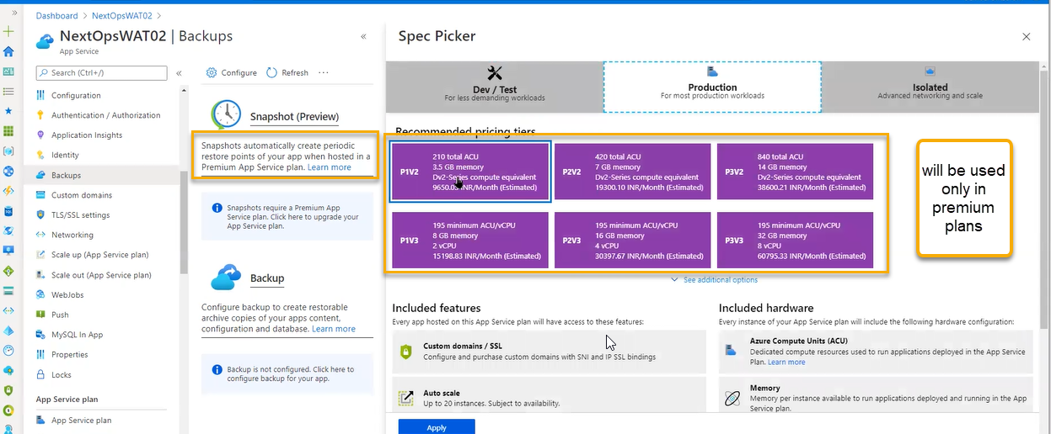

Custom Domains

For our website if we don’t want to use Azure provided URL

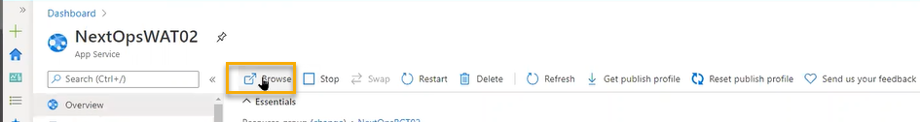

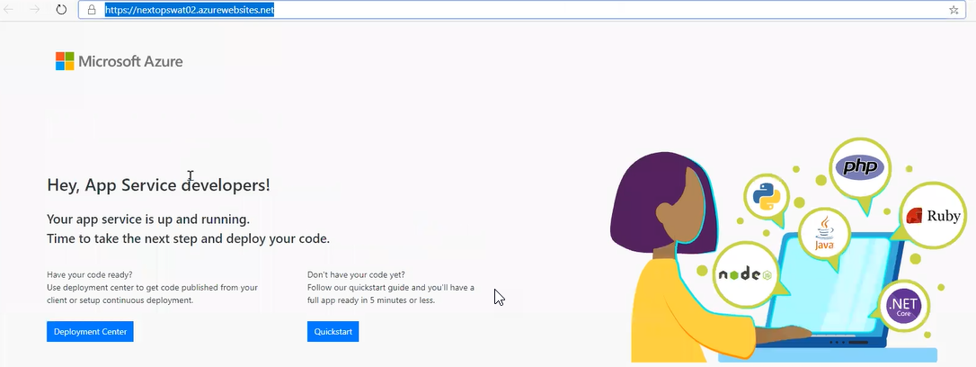

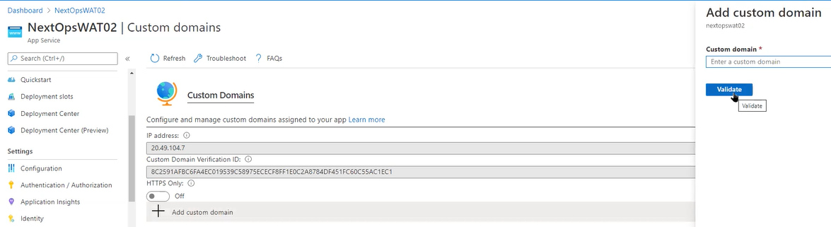

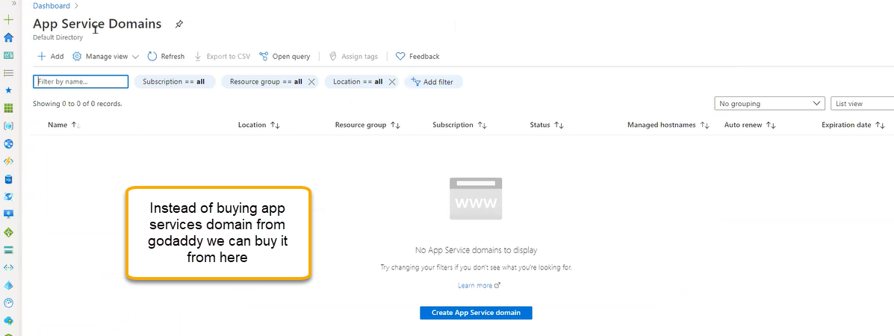

TLS/SSL

Transport layer security and socket layer security

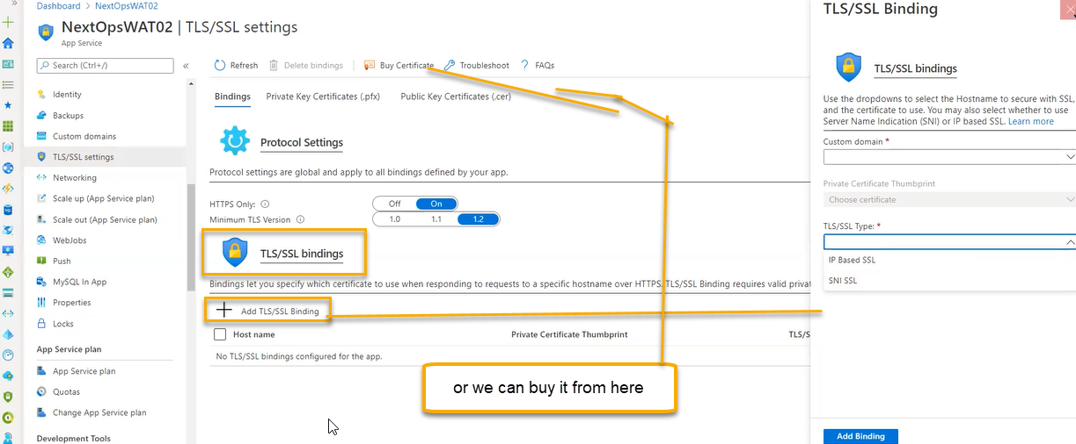

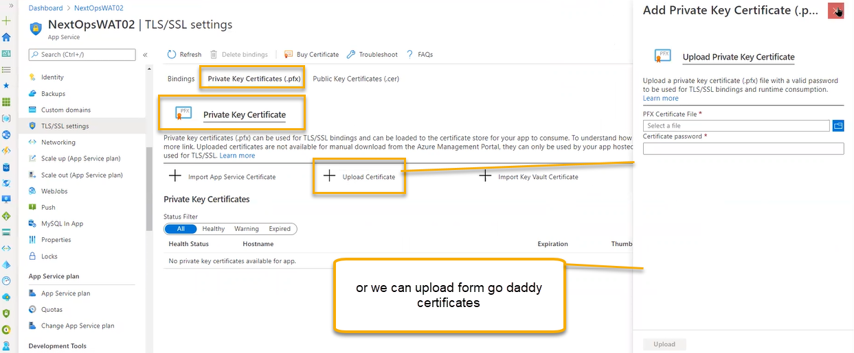

Or we can import from key vault

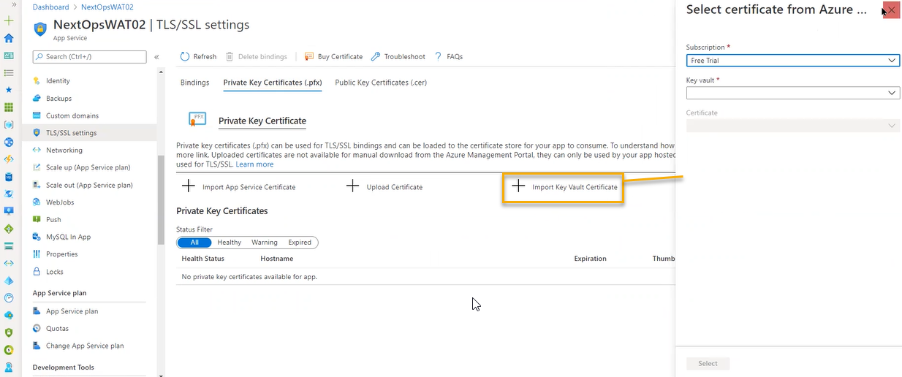

The url generated by azure is temporary and if you are hosting any website, we need certificate in place

Networking

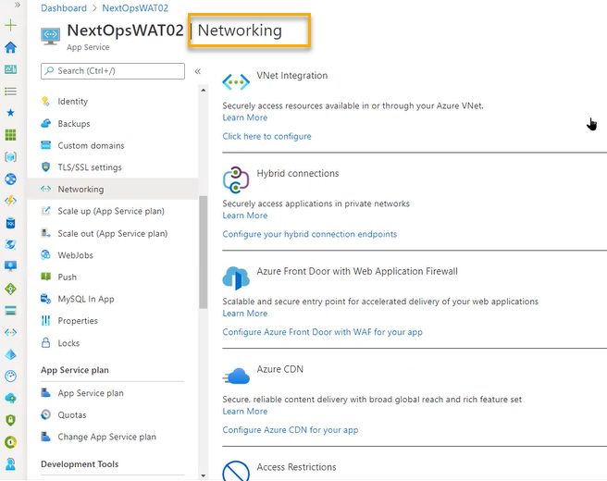

If you want to integrate the web app to our Vnet( we can do it by standard/ premium/isolated ( a dedicated vnet is associated )

A web app is always independent of vnet

Web app will not come inside the vnet however inside vnet resources it will connect ( inside the vnet we will place VM and inside the VM we will place sql)

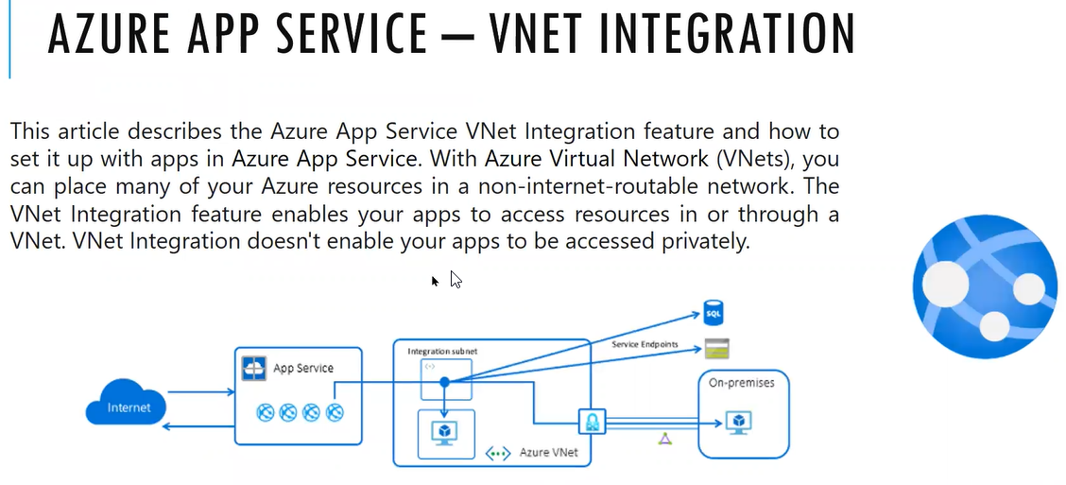

If you select the isolated then App services will sit inside the vnet

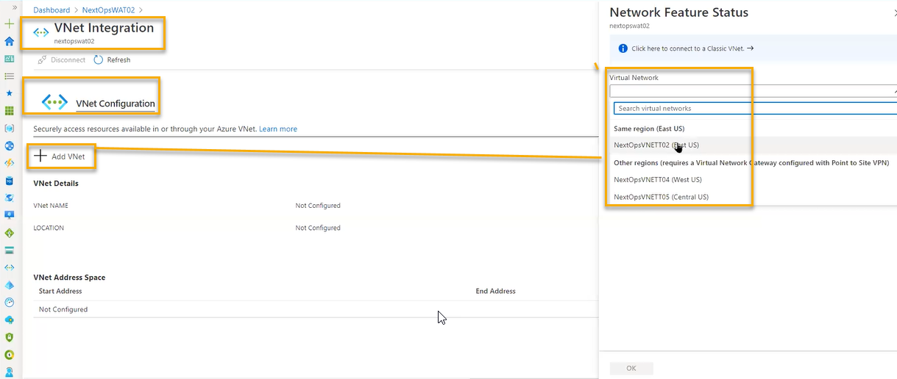

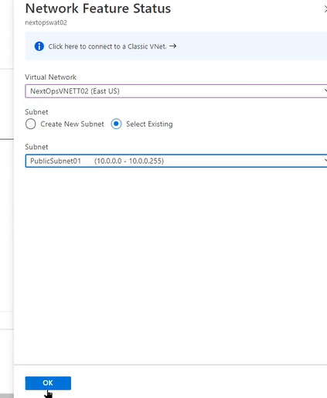

Hybrid connections

There will be some broker called Hybrid connection manager will acts a proxy without connecting directly to Vnet. For that we need to dedicate one machine in Vnet

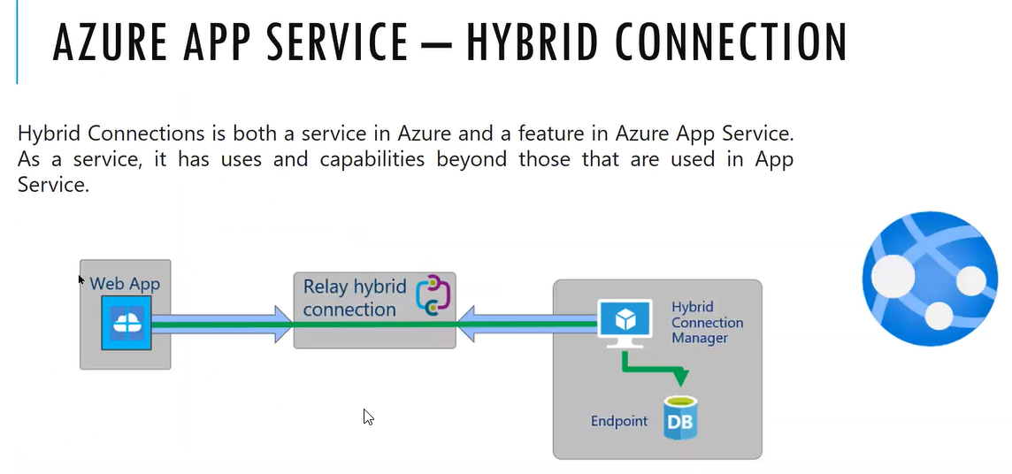

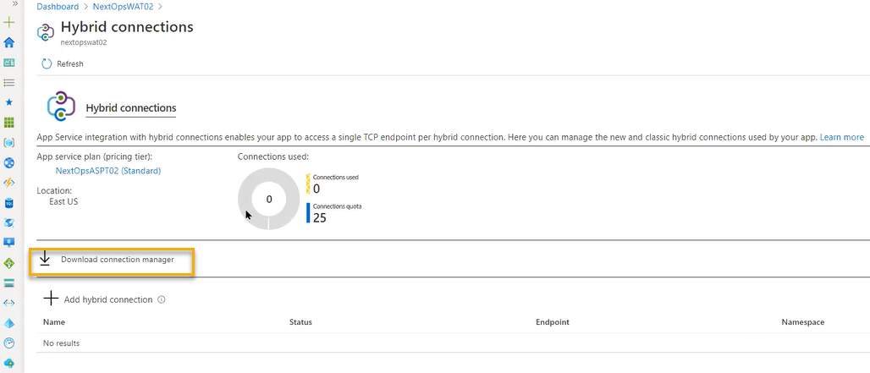



Using this hybrid connections, we can set up to the end points by clicking the Add hybrid connection

Azure Front door

It is a regional level firewall and it is a load balancer (how the traffic manager will work on a regional level) in the same way it will work for Azure front door

We need to create then front door

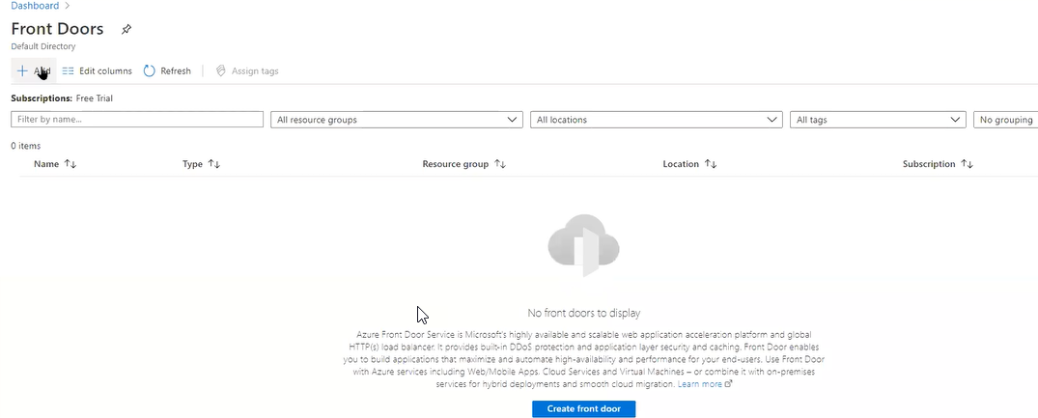

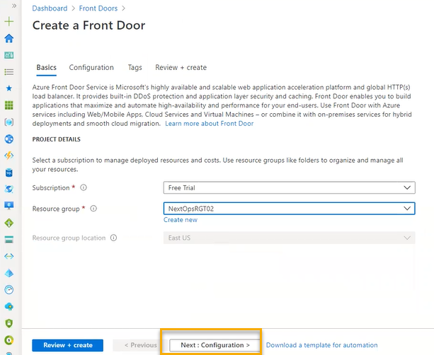

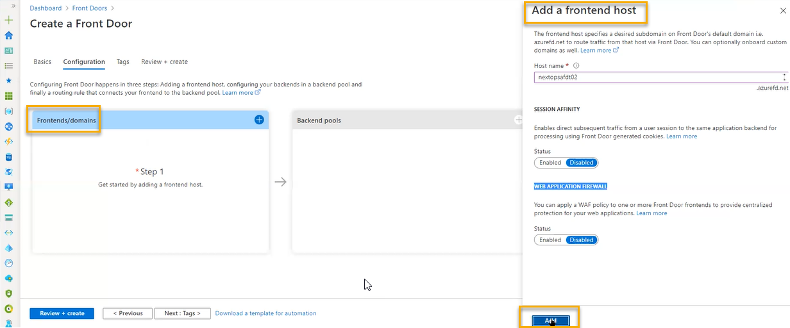

We can add any backend pool

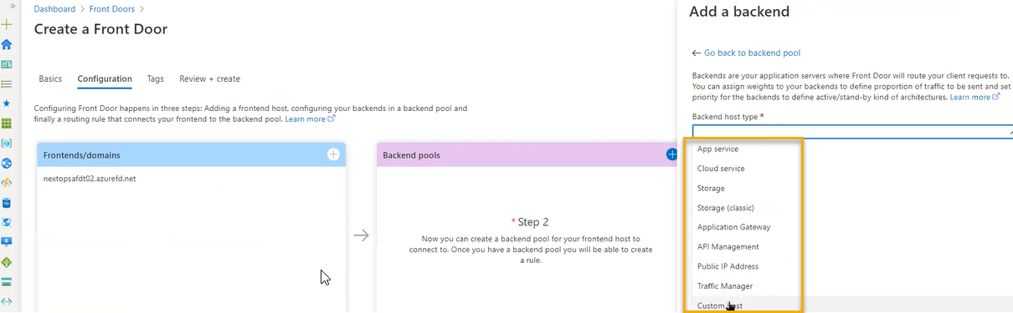

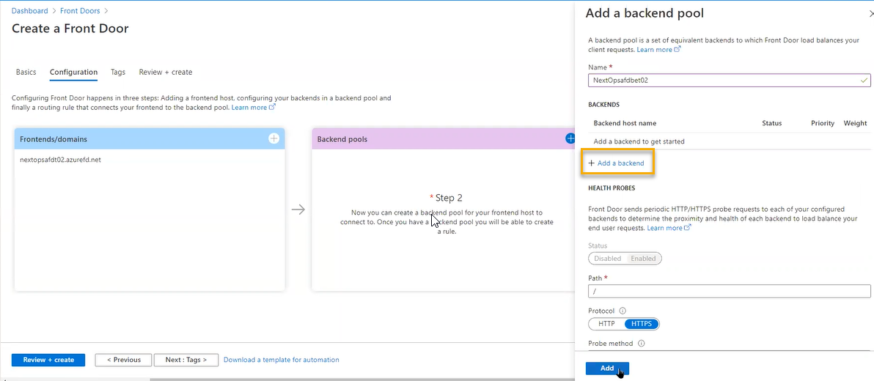

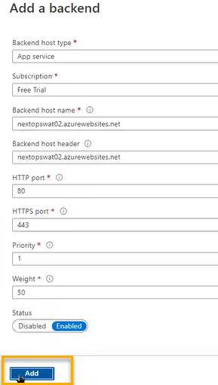

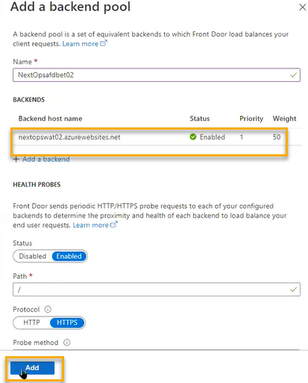

Routing:

Patterns to match: Path to match

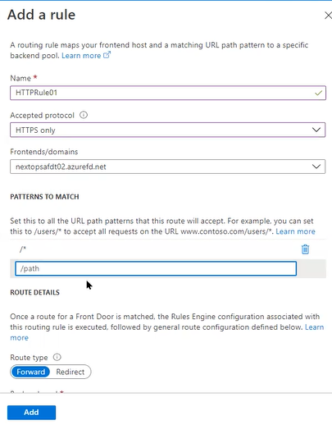

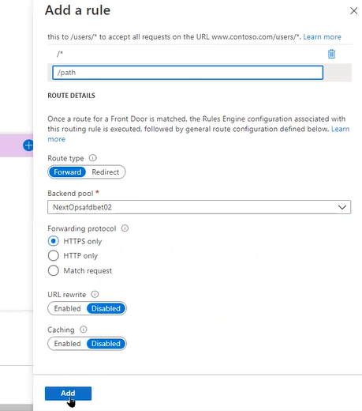

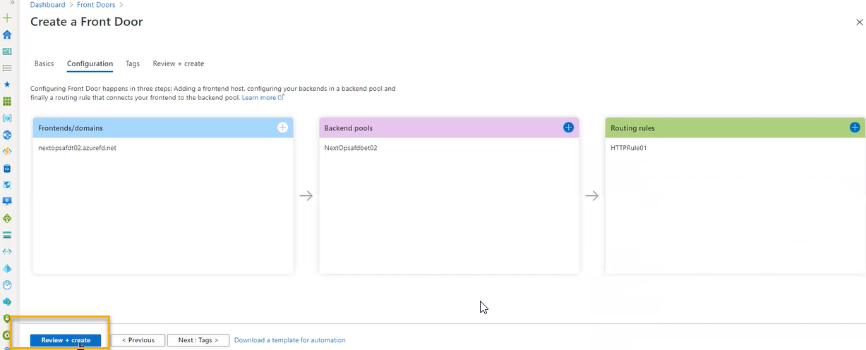

It is like application gateway the difference is front door will work with between the regions

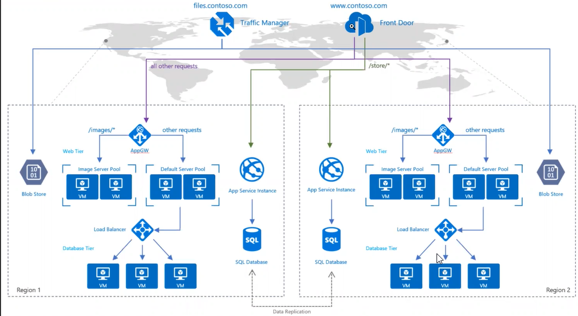

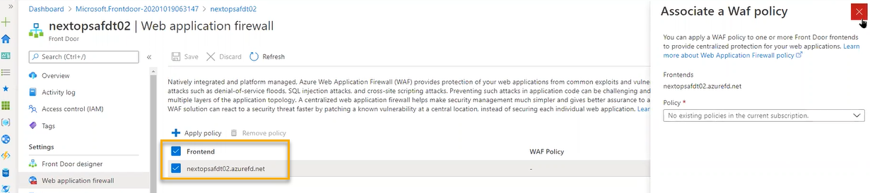

It is just like top 10 safety steps

Rules engine configuration

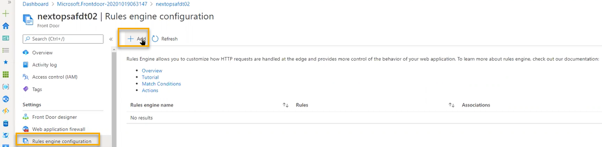

Based on geographic if you want t send any request , cache related expiry handle, we will define the rules where the request is coming

We will need developers help to configure this

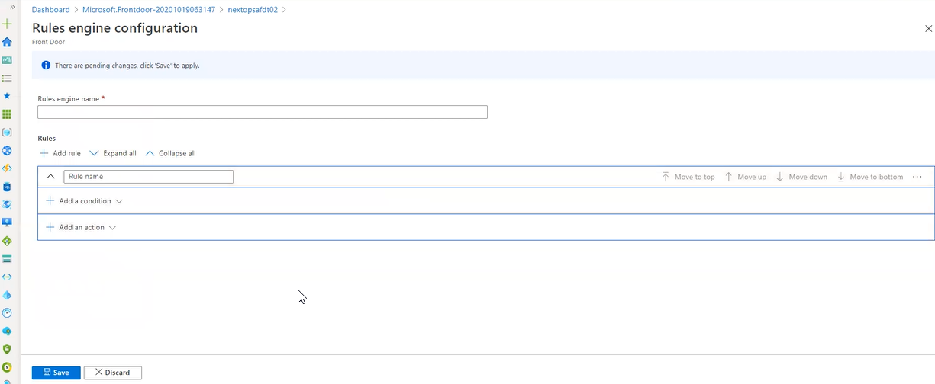

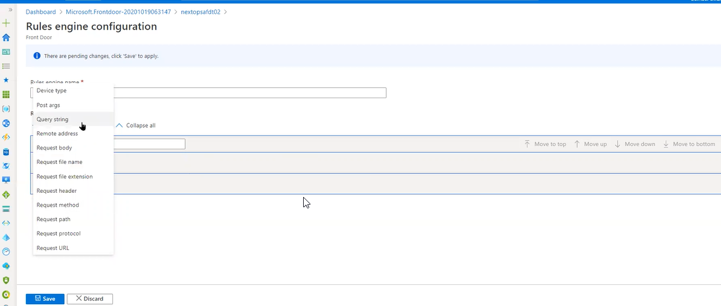

Azure content delivery network

If we are hosting streaming and if you want to deliver any videos or images it will go to nearest cache point from that point it will bring the data

It is just like POP

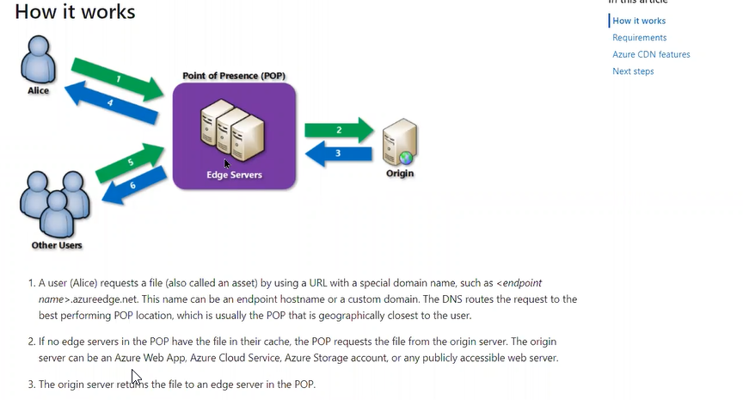

Access restrictions

Who wants to give access/who does not want to give access we can mention here

It just like NSG

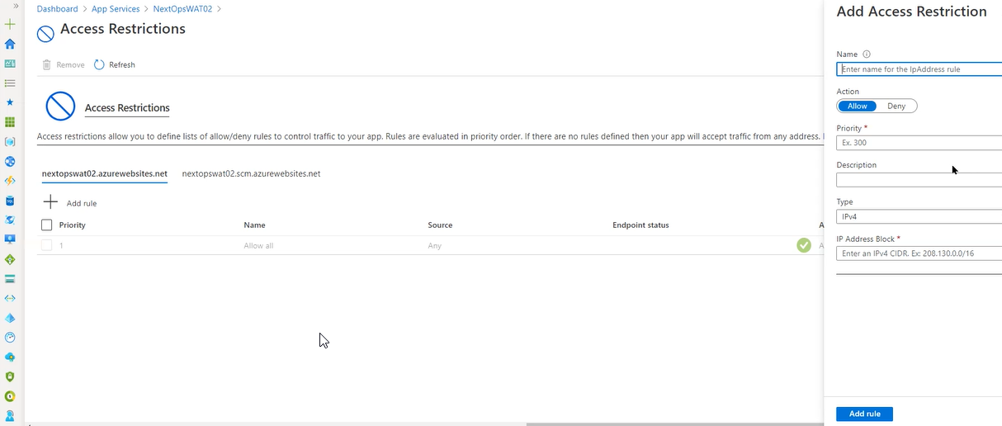

Scale Up

vertical scaling. It is just like a plan change. For the existing server we are adding the resources

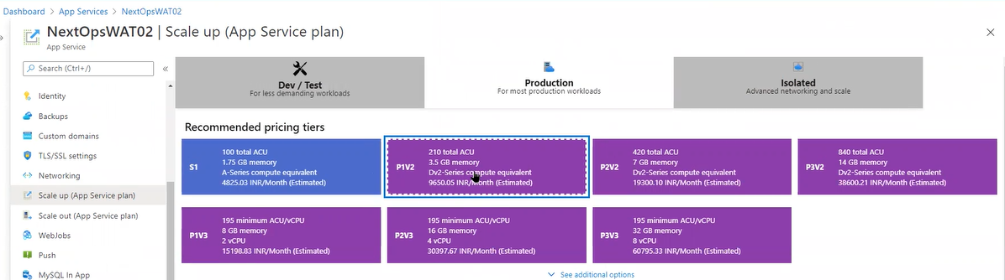

Scale out

Horizontal scaling: Adding the additional servers

Web Jobs

It is just like schedule jobs. In the background if it is run a continuous script or any garbage collection script to run periodically/continuously

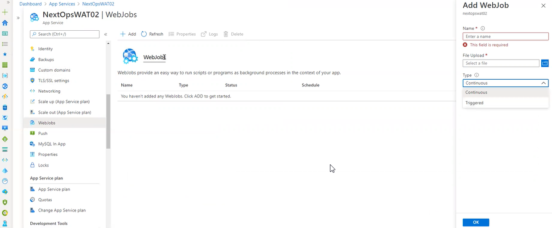

In Linux we called cronjobs and windows it is a schedule job and in web application we have web apps

For performance recycle, optimize

Push

If the web application is integrated with mobile phone, we connect the notification hub

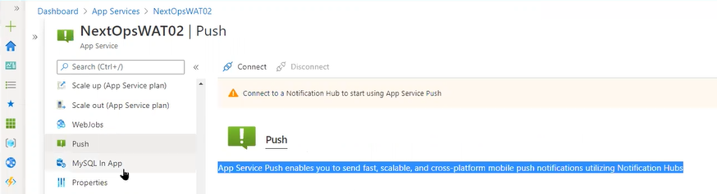

My SQL In App

We can integrate the database here it will share the resources which are sharing with web services

The performance might be degraded because in the same app service plan already two slots are running

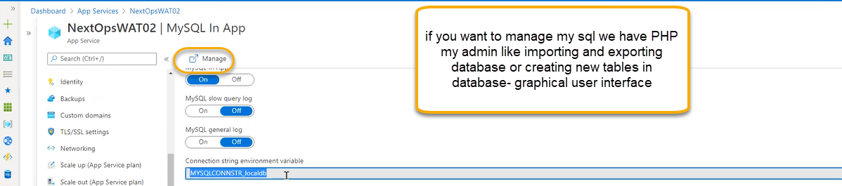

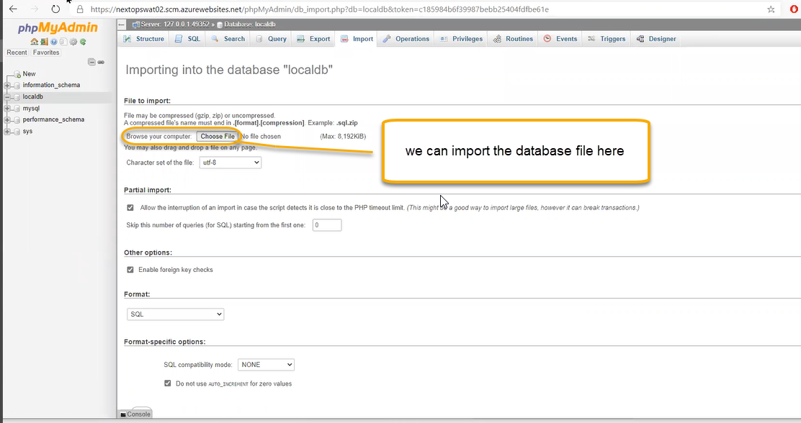

( OR)

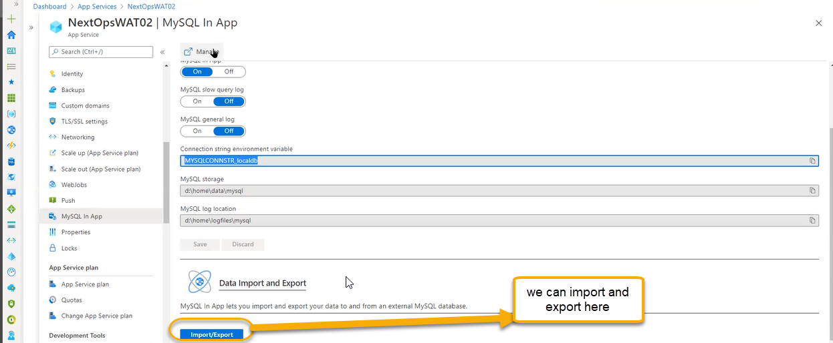

App service plan

If you click it will open the app services plan page and if you do any thing it is applicable to all slots

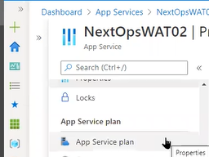

We can see how many are running by the below page

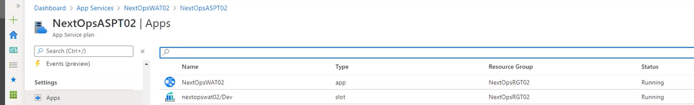

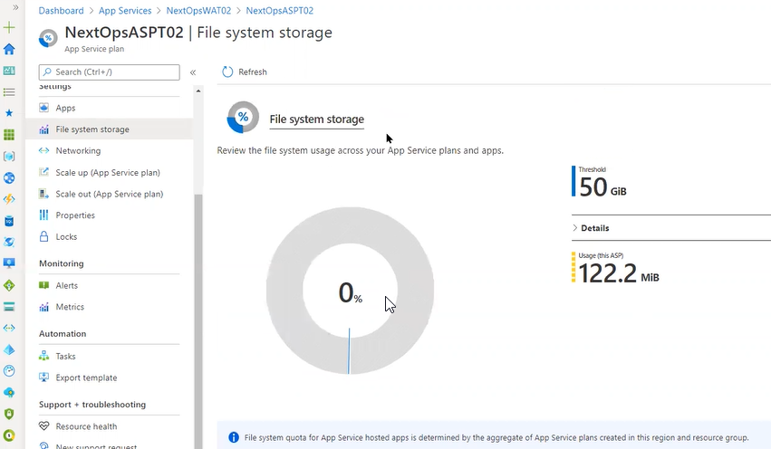

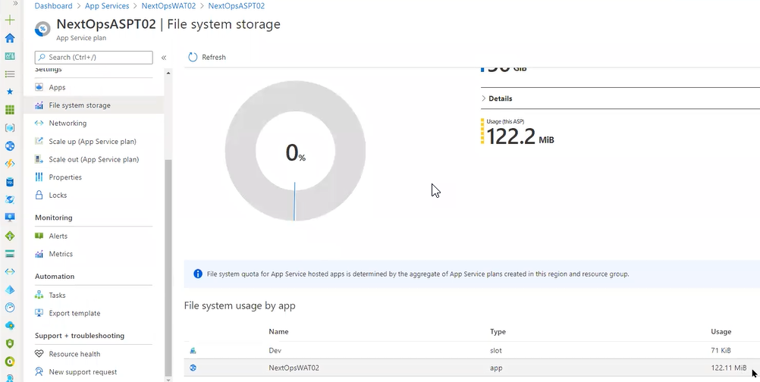

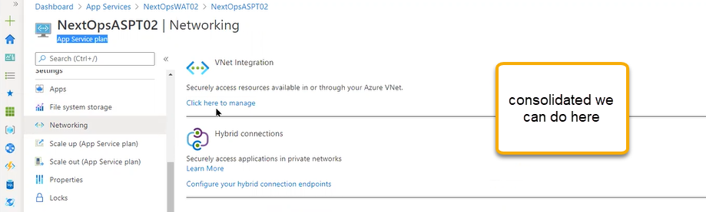

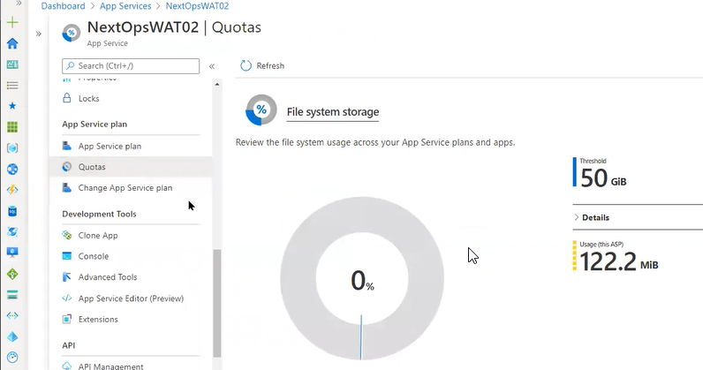

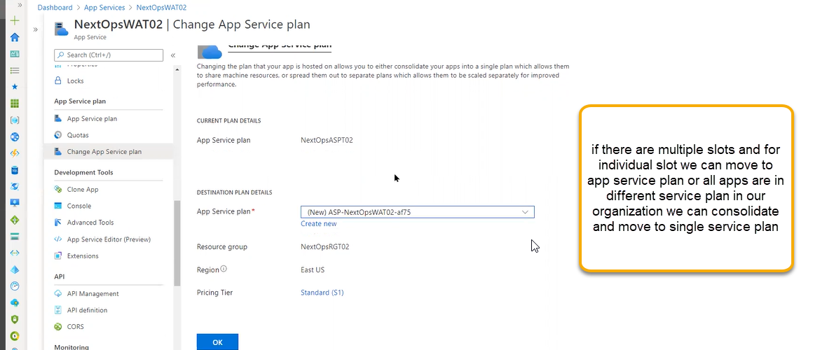

Clone App

We can do in a regional copy

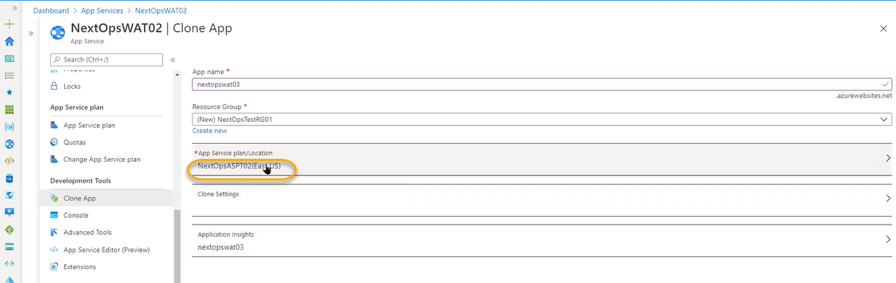

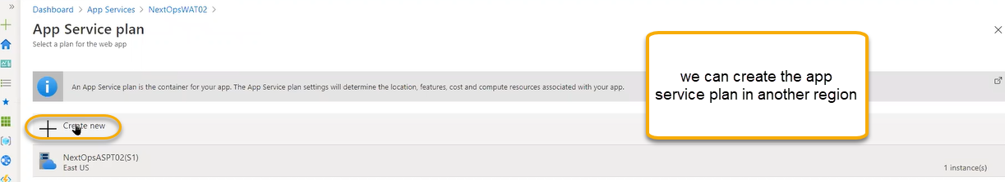

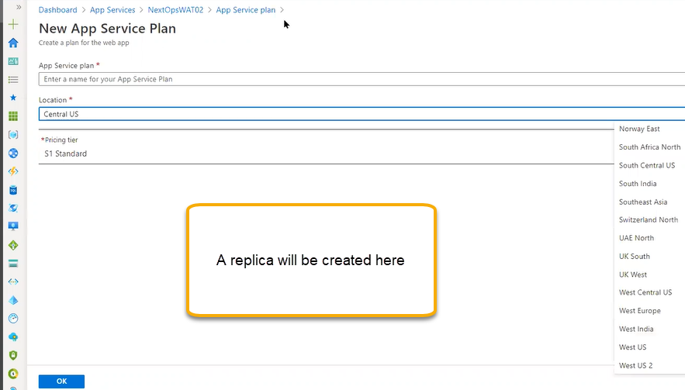

If we need a high availability for a regional level we can create the clone multiple and if we place in azure front door that respective regions it will handle

Console

Back end running platform we will have minimum access

The web app is running in one machine which we don’t have any access and we are having an issue with RDP

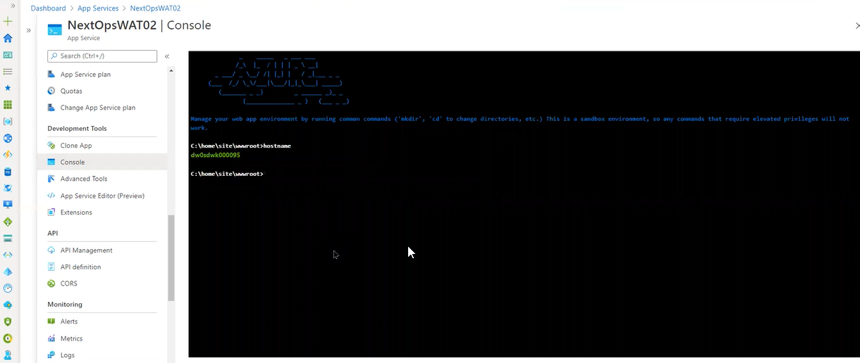

Advanced tools

If want to upload the files

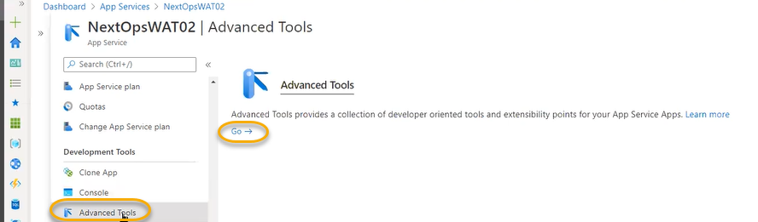

These are called KUDU tools which will be used for developers

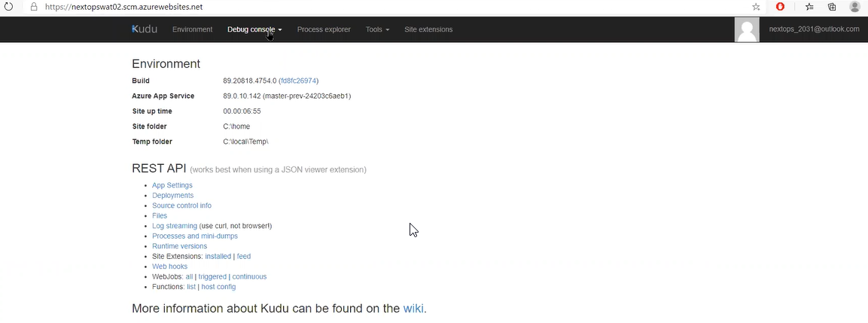

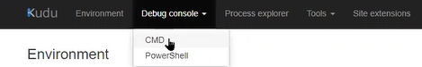

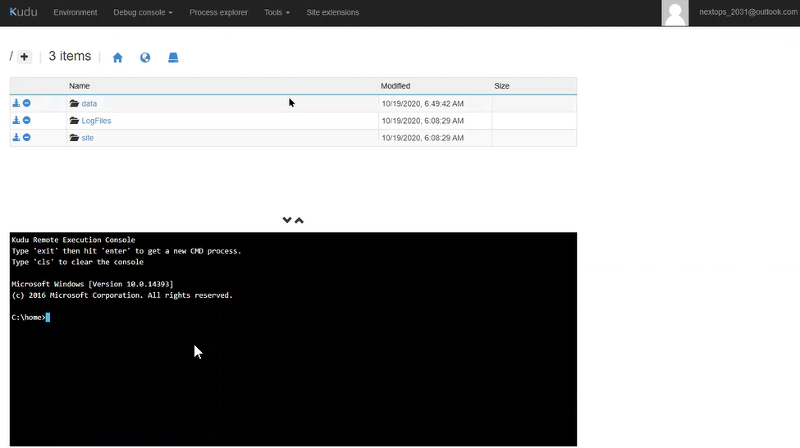

If you click on the site

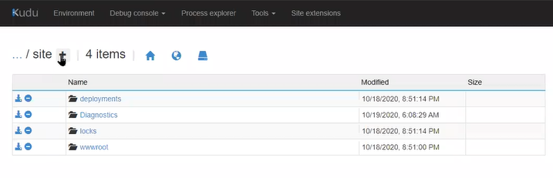

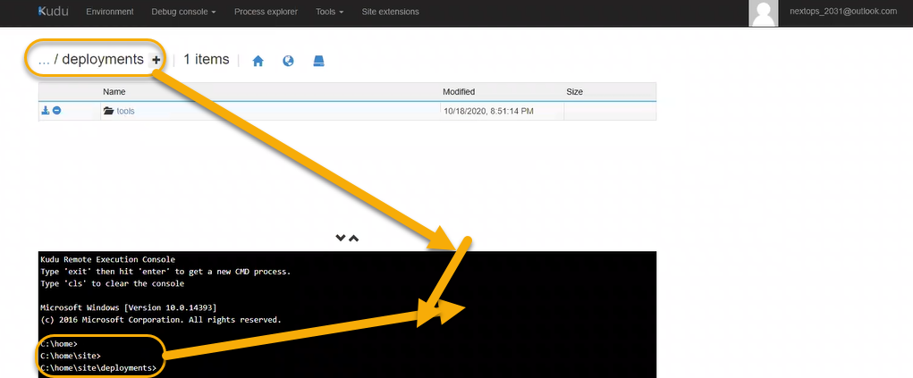

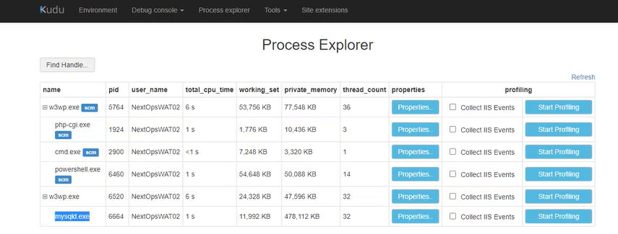

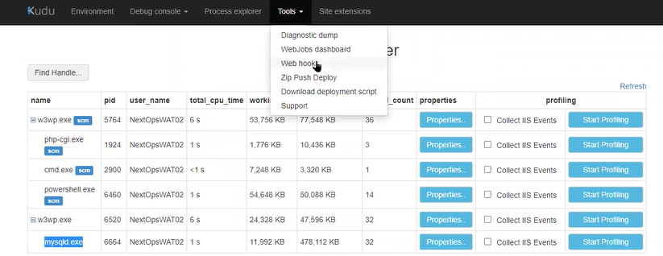

Web hook is like for cronjobs

App service editor:

If you want to edit the code we can do it from here like visual studio software they are bringing to the browser

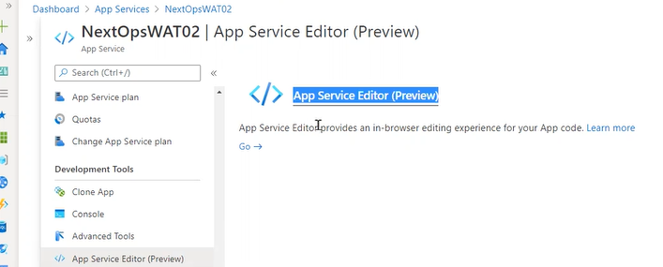

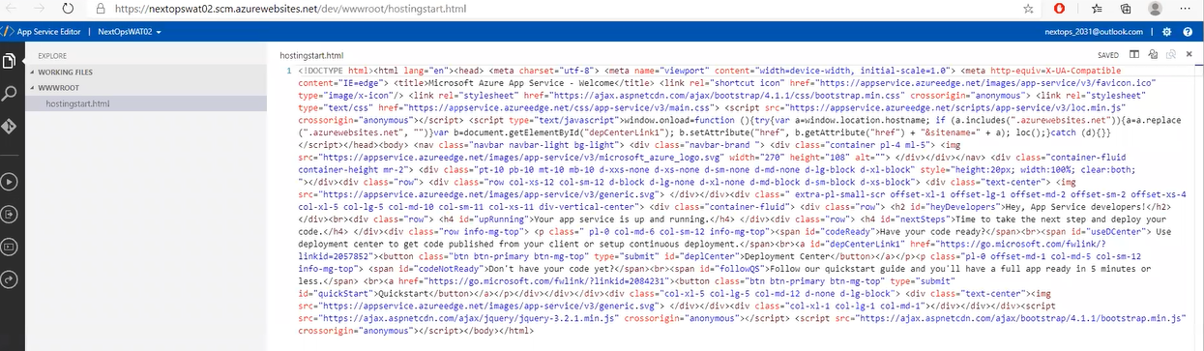

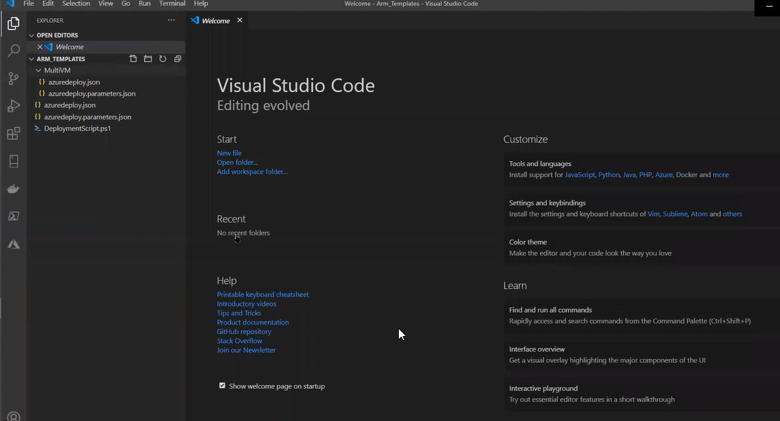

API Management

Application programing interface for few applications they will integrate the API. IRSCTC or any kind of information or if we are checking PNR Status we can also pull it from other websites other than IRSCTC

How the database is connected to all other websites along with IRSCTC we can do it from API

Which is purely related to programming

API definition: How the API has to write